Shane Tinsley – 11/11/2023 Assignment 6.2

https://github.com/Zebtha/csd-310.git

Command Line

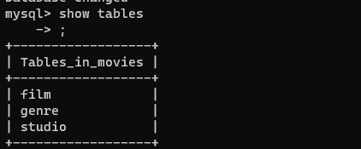

VS Code

PyCharm

